

# TABLE OF CONTENTS

TABLE OF CONTENTS 1

Introduction 2

Requirements 2

Disclaimer and Permitted Use 2

Installation 3

Install R and RStudio 3

Download R packages from GitHub 3

Install R packages in RStudio 5

Walkthrough 7

Launch BulletAnalyzr 7

Upload the bullets 8

Adjust the crosscut locations 9

Adjust the groove placements 9

Comparison results report 10

Additional Information 13

Citing the package 13

License 13

Permitted use statement 14

# Introduction

BulletAnalyzr is a forensic tool that uses 3D imaging and advanced algorithms to compare bullets and determine if they were fired from the same gun. The application scans bullet surfaces at high resolution and automates much of the comparison process, while still giving forensic examiners intuitive controls to review and adjust the results.

* **Interactive Visualization:** Upload and view 3D renderings of your bullet scans (x3p format) and examine crosscut profiles with adjustable parameters.
* **Automated Analysis:** The software automatically processes your bullet scans, identifying crosscut locations, removing grooves, extracting signals, and measuring similarities between signals.
* **Manual Refinement Controls:** Fine-tune automated decisions using intuitive sliders at each step of the analysis.
* **Comprehensive Reporting:** Generate and export detailed comparison reports in a professional, shareable format.
* **Free and Open-Source:** BulletAnalyzr is an open-source and free-to-use tool.

BulletAnalyzr bridges the gap between sophisticated algorithmic analysis and practical forensic workflows, making advanced bullet comparison techniques easily accessible to examiners.

# Requirements

BulletAnalyzr version 1.0.0 has the following requirements. Failure to meet these requirements makes any potential results unreliable.

* Bullets must be 9 mm in caliber.
* Bullets must display right-twist rifling.
* Bullets must have exactly 6 land engraved areas.
* Bullets cannot have missing land engraved areas.

# Disclaimer and Permitted Use

**Disclaimer**

The software is in testing and has not yet been fully validated. CSAFE is not liable for its accuracy or reliability.

**Permitted Uses**

* **Research:** Use the software for academic or scientific research related to forensic bullet comparison.
* **Testing:** Use the software for internal testing within forensic labs to evaluate its performance.

**Discouraged Uses**

* **Casework and Court Testimony:** The statistical model implemented by this software has not yet been applied to the full range of bullets that could be encountered in casework or investigations. Therefore, we have not identified the conditions under which the approach can be expected to provide accurate and reliable results. Furthermore, the statistical model has not yet undergone a robust validation study; accuracy metrics, like false-positive and false-negative error rates, have not been established.

Refer to the full Permitted Use Statement at the end of this document for more information.

# Installation

You will need to install R, RStudio, BulletAnalyzr, and supporting R packages.

## Install R and RStudio

Total Estimated Time: 20-30 minutes

* **Install R** from <https://cran.r-project.org/>
* **Install RStudio** from <https://posit.co/download/rstudio-desktop/>
* **(Windows only) Install Rtools** from <https://cran.rstudio.com/bin/windows/Rtools/>. Select the version corresponding to your version of R.

## Download R packages from GitHub

Total Estimated Time: 20-30 minutes

* **Download grooveFinder** from GitHub
  + Go to <https://github.com/heike/grooveFinder>
  + Click the green Code button and select Download Zip. (Figure 1)
  + Double-click on the downloaded file to unzip it. You may save the unzipped folder anywhere on your computer. By default, the unzipped folder will be named "grooveFinder-master". You may rename the folder.

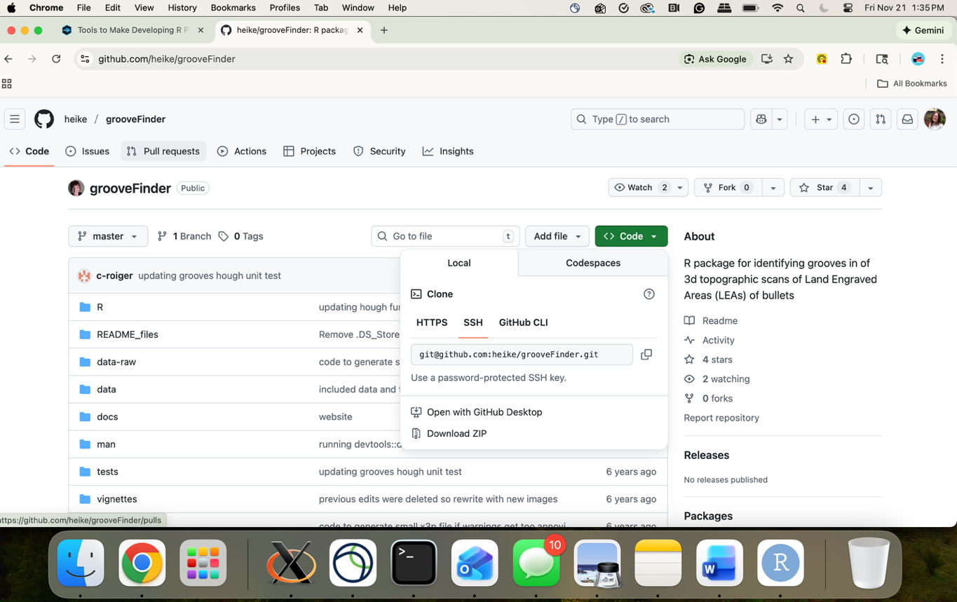

Figure 1. Click Code and then Download ZIP on the grooveFinder GitHub page to download grooveFinder.

* **Download x3ptools** from GitHub
  + Go to https://github.com/heike/x3ptools
  + Click the green Code button and select Download Zip. (Figure 2)
  + Double-click on the downloaded file to unzip it. You may save the unzipped folder anywhere on your computer. By default, the unzipped folder will be named "x3ptools-main". You may rename the folder.

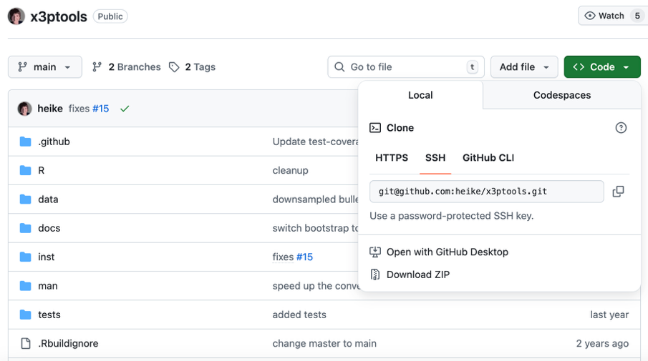

Figure 2. Click Code and then Download ZIP on the x3ptools GitHub page to download x3ptools.

* **Download bulletxtrctr** from GitHub
  + Go to https://github.com/heike/bulletxtrctr
  + Click the green Code button and select Download Zip. (Figure 3)
  + Double-click on the downloaded file to unzip it. You may save the unzipped folder anywhere on your computer. By default, the unzipped folder will be named "bulletxtrctr-main". You may rename the folder.

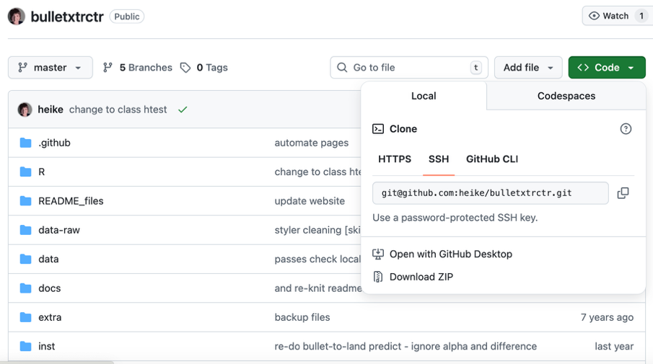

Figure 3. Click Code and then Download ZIP on the bulletxtrctr GitHub page to download bulletxtrctr.

* **Download BulletAnalyzr** from GitHub
  + Go to <https://github.com/CSAFE-ISU/bulletAnalyzr>
  + Click the green Code button and select Download Zip. (Figure 4)
  + Double-click on the downloaded file to unzip it. You may save the unzipped folder anywhere on your computer. By default, the unzipped folder will be named "bulletAnalyzr-main". You may rename the folder.

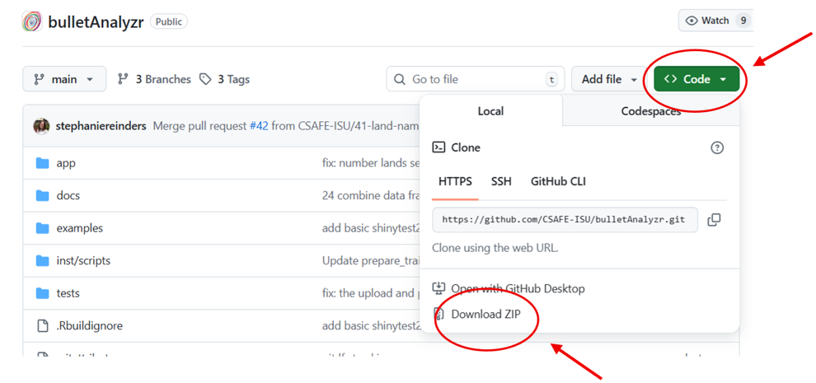

Figure 4. Click Code and then Download ZIP on the BulletAnalyzr GitHub page to download BulletAnalyzr.

## Install R packages in RStudio

Total Estimated Time: 45-50 minutes

Install packages from the Comprehensive R Archive Network (CRAN).

* Open RStudio.
* Navigate to the RStudio Console. (Figure 5)
* Copy and paste the following lines of code into the Console after the “>” symbol. (Figure 5)

# Install packages from CRAN

cran_packages <- c("bsicons", "bslib", "curl", "devtools", "dplyr", "DT", "ggplot2", "pagedown",

"randomForest", "rgl", "sessioninfo", "shiny", "shinyBS",

"shinycssloaders", "shinyjs")

for (pkg in cran_packages) {

install.packages(pkg)

}

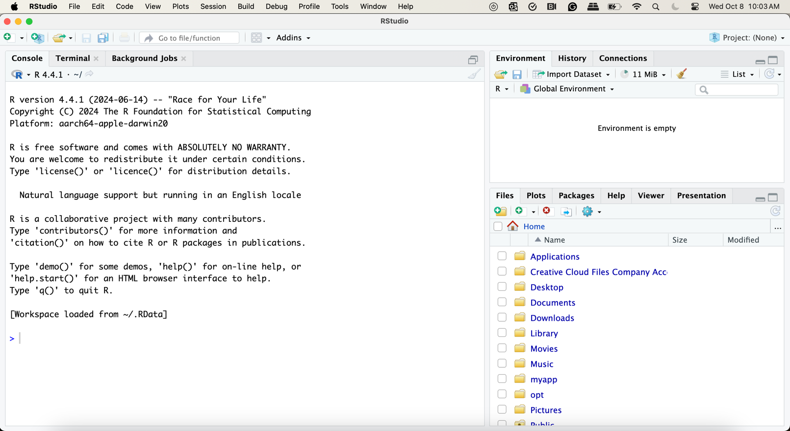

Figure 5. The Console in RStudio.

Install the GitHub packages you downloaded in the previous section.

* Navigate to the grooveFinder folder in the Finder (Mac) or File Explorer (Windows) that you downloaded and unzipped during installation.
* Double-click on grooveFinder.Rproj. This will open grooveFinder in RStudio and “grooveFinder-master” is displayed in the upper right corner. (Figure 6)
* Open the Build tab and click Install to install grooveFinder. (Figure 7)

Repeat these steps for x3ptools, bulletxtrctr, and BulletAnalyzr.

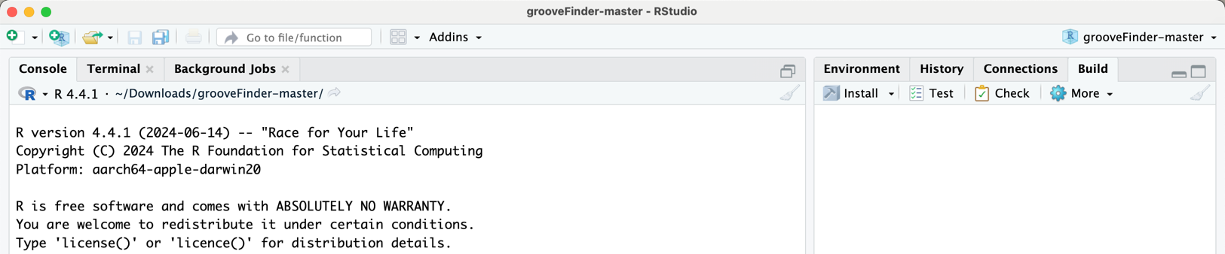

* Figure 7

Figure 6. The grooveFinder R package is open in RStudio.



Figure 7. Click Build. Then click Install to install grooveFinder.

# Walkthrough

Total Estimated Time: 15-20 minutes

BulletAnalyzr includes 3d scans from the Hamby-Brundage bullet set #44 provided by CSAFE, so you can practice the workflow.

## Launch BulletAnalyzr

* Open RStudio.
* Type or copy and paste the following lines of code after the “>” symbol.

library(bulletAnalyzr)

bulletAnalyzrApp()

* Click Begin on the BulletAnalyzr home screen. (Figure 8)

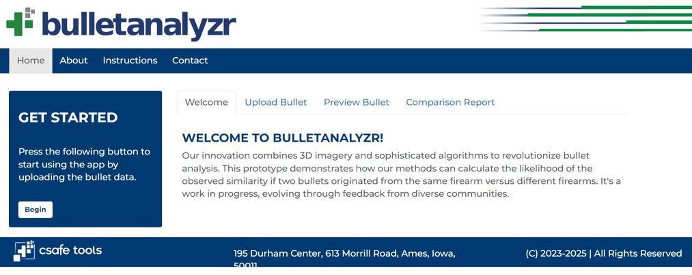

Figure 8. Click Begin on the BulletAnalyzr home page to get started.

## Upload the bullets

* Upload the first bullet.
  + Click Browse and navigate to the BulletAnalyzr folder. Then go to examples > Hamby-44 > Barrel 1 > Bullet 1.
  + Select all 6 files in this folder. Each x3p file is an image of a bullet land engraved area. (Figure 9)
  + Give the bullet a name (e.g., Bullet 1). (Figure 9)
  + Add it to the Comparison List. (Figure 9)
  + A preview of each land is shown in the main window. Rotate and zoom the lands for different perspectives. (Figure 9)
* Upload the second bullet.
  + Repeat the same process for the Bullet 2 images: Hamby-44 > Barrel 1 > Bullet 2.

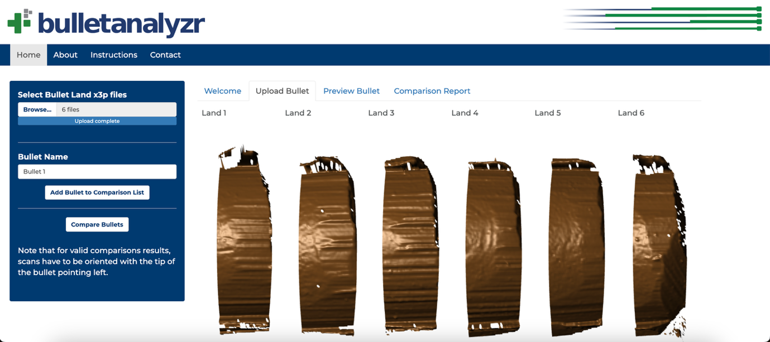

Figure 9. Click Browse to upload the scans from the first bullet. Give the bullet a name. Click Add Bullet to Comparison List.

## Adjust the crosscut locations

BulletAnalyzr attempts to identify suitable crosscut locations. The crosscuts are displayed as light grey lines on the lands.

* Adjust the crosscuts for Bullet 1.
  + Select Bullet 1 from the drop-down menu if it isn’t already selected.
  + Use the sliders to adjust the crosscuts if needed.
  + Click Finalize Crosscut when satisfied.
* Adjust the crosscuts for Bullet 2.
  + Select Bullet 2 from the drop-down menu.
  + Use the sliders to adjust the crosscuts if needed.
  + Click Finalize Crosscut when satisfied.
* When both bullets are ready, click Compare Bullets.

## Adjust the groove placements

In order to capture the full land, the scans also contain parts of the grooves. BulletAnalyzr needs to remove the grooves before further processing. The app attempts to locate the grooves on the crosscut profile, but manual adjustment is sometimes required.

* Adjust the groove on land 1 of Bullet 1. (Figure 10)
  + Select Bullet 1 and Land 1 from the drop-down menus.
  + The vertical red lines on the crosscut profile plot indicate the left and right groove locations. Everything to the left of the left groove line and everything to the right of the right groove line will be discarded.
  + Adjust the groove locations using the slider bars to keep as much of the land as possible. (Figure 11)
  + Click Save Grooves when satisfied.
* Repeat for all lands on both bullets.
* Once grooves are defined, click Next Step.

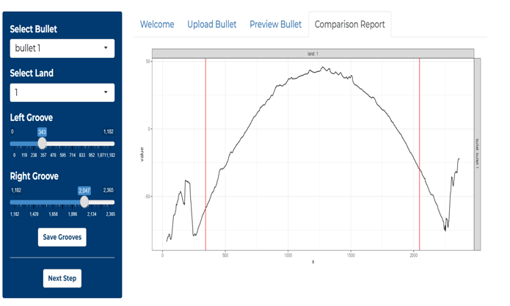

discard

discard

Figure 10. The profile plot of Bullet 1 Land 1. The red lines indicate the current location of the grooves. The profile between each groove and the side of the plot will be discarded.

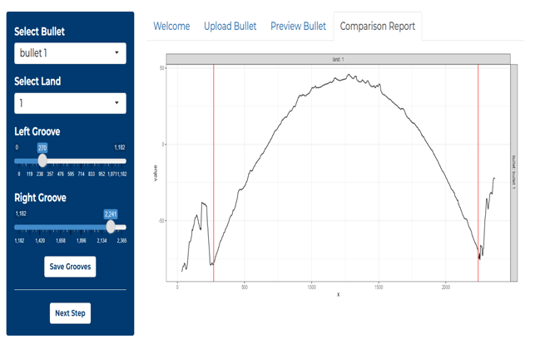

Figure 11. The profile plot of Bullet 1 Land 1 after the grooves are moved.

## Comparison results report

Behind the scenes, BulletAnalyzr extracts signals from the lands. Each signal from Bullet 1 is compared to each signal from Bullet 2 by measuring features such as consecutive matching striae.

* The output page displays the comparison results.
* Click Download Report to download a copy of the report.
* Click Download Data to download a copy of the data.
* This is what the report page will look like:

Figure 12. The output page of the comparison results.

* The bullet-to-bullet score matrix shows the similarity score between Bullet 1 and Bullet 2. Scores range from 0 to 1, with 0 indicating no similarity and 1 indicating perfect similarity. Bullets 1 and 2 have a similarity score of 0.90, indicating similarity. The phase test score and the probability of false identification give more information about the interpretation of the similarity score.

Figure 13. The bullet-to-bullet score matrix.

* BulletAnalyzr compares each land on Bullet 1 with each land on Bullet 2 to measure their similarity (Figure 14). The resulting land-to-land score matrix displays the similarity scores for every possible land pair. Each unique alignment of lands between the two bullets is referred to as a *phase*. For bullets with six lands, there are six possible phases (Figure 15). The selection of these phases is called phase-selection grouping. In the land-to-land matrix, the cells corresponding to the phase with the highest average similarity score are outlined with dark boxes and referred to as the in-phase. The other possible phase alignments are called off-phases.

Figure 14. The land-to-land score matrix.

Figure 15. The six possible phase alignments. This figure is from Md Azizul Islam’s master’s creative component, “Selective Inference for Bullet Comparisons in Forensic Analysis.” 2025. Iowa State University.

* To determine whether two bullets originate from the same or different sources, we perform a *t*-test. The null hypothesis assumes no difference between the mean similarity scores of matching and non-matching lands. The alternative hypothesis states that the mean similarity score for matching lands is greater than that for non-matching lands. In other words, matching lands from the same barrel or firearm are expected to show higher similarity values than non-matching lands.

However, selecting a specific phase introduces selection bias and increases the probability of false identifications (Type 1 errors). To address this issue, BulletAnalyzr implements a new statistical approach called the *phase test*, designed to correct the inflation of Type I errors that occur when traditional *t*-tests are applied under phase-selection grouping. The phase test employs a new test statistic based on order statistics from the six-phase means. Specifically, it measures the difference between the phase with the highest average similarity score and the phase with the 4th highest average similarity score. This value is defined as the *phase test score*.

* The phase test score and the probability of false identification can be found below. For the example bullets, the probability of a false identification is less than 1 in 10 million.

Figure 16. The phase test score and the probability of false identification.

# Additional Information

## Citing the package

If you use BulletAnalyzr in research, please cite:

* Eric Hare, Heike Hofmann, Alicia Carriquiry. "Algorithmic approaches to match degraded land impressions." Law, Probability and Risk, Volume 16, Issue 4, December 2017, Pages 203-221. <https://doi.org/10.1093/lpr/mgx018>
* Eric Hare, Heike Hofmann, and Alicia Carriquiry. "Automatic Matching of Bullet Land Impressions." The Annals of Applied Statistics, Volume 11, Number 4, 2017, pp. 2332-56. <http://www.jstor.org/stable/26362188>

## License

BulletAnalyzr is provided under the GNU General Public License version 3. The full license is available at <https://github.com/CSAFE-ISU/bulletAnalyzr/blob/main/LICENSE.md>.

## Permitted Use Statement

**Permitted Use of CSAFE’s BulletAnalyzr Software**

**Effective Date:** April 4, 2025

**Overview**

This document outlines permitted uses of the Center for Statistics and Applications in Forensic Evidence’s BulletAnalyzr software. The software is currently undergoing alpha testing and may be used in research and additional testing within forensic labs. The software is not yet validated for casework.

**Permitted Uses**

* **Research:** Use the software for academic or scientific research related to forensic bullet comparison.
* **Testing:** Use the software for internal testing within forensic labs to evaluate its performance.

**Discouraged Uses**

* **Casework and Court Testimony:** The statistical model implemented by this software has not yet been applied to the full range of bullets that could be encountered in casework or investigations. Therefore, we have not identified the conditions under which the approach can be expected to provide accurate and reliable results. Furthermore, the statistical model has not yet undergone a robust validation study; accuracy metrics, like false-positive and false-negative error rates, have not been established.

**User Responsibilities**

Users should:

* Follow the permitted use guidelines.
* Treat findings as preliminary and unsuitable for formal conclusions.

**Disclaimer**

The software is in testing and not fully validated. CSAFE is not liable for its accuracy or reliability.

**Contact Information**

Center for Statistics and Applications in Forensic Evidence

195 Durham Center  
613 Morrill Road  
Ames, Iowa 50011  
csafe@iastate.edu